Amstrad/Schneider PC 1512 Emulation
In contrast to virtualization, emulation programs are able to replicate the behavior of another computer system 1:1. This high quality of compatibility comes at the price of emulation
at the expense of performance speed. Fortunately, however, all common computer systems of our time are able to replicate the computer systems to be emulated, some of which were introduced 30 years ago – without any loss of speed. If the emulated system seems slow, it may only be because the PC from the old days was really that slow.
This document describes the emulation, commissioning and operation of an emulated Amstrad
/Schneider PC1512s from 1986. The basic platform is a current Windows computer with Windows 10 or a server variant.
All changes that are made on the emulated PC1512 have no influence on your base system. So you can format the emulated hard drive with a clear conscience without your "real" PC really losing data. Nevertheless, the author assumes no liability. In principle, the ROM images and operating systems used here are subject to copyright. Ideally, you should own the Amstrad/Schneider PC1512.
We need:
- Base Computer - Host System (your PC running Windows 10)
- Emulations-Software (86Box)
- ROM images of the Amstrad/Schneider PC1512
- Four operating system floppy disk images
- A disk image
Step 1 – Emulation Software
Search for "86Box" in your favorite Internet search engine. You may come across the GitHub website, scroll down there and find the hint which version you should download. Alternatively, use our static link to a complete package. Unzip the archive at a desired location on your computer.
The result should look something like this:
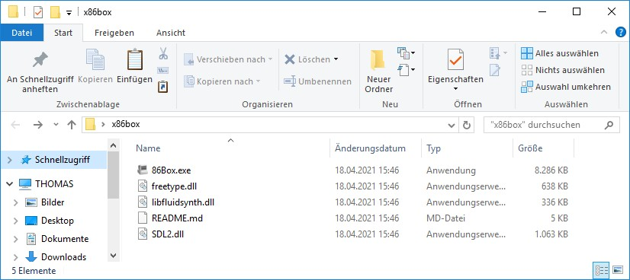
Start 86box.exe by double-clicking, the following warning message from Windows Defender may appear:
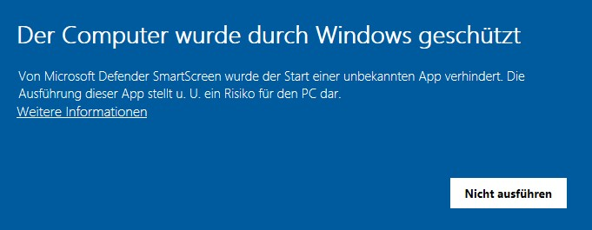
Click on "More information" and select "Run anyway". The following error dialog will now appear – this is perfectly normal:
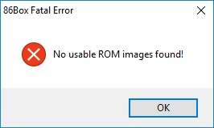
Confirm the error with "OK", the program will close automatically.
Step 2 – ROMs
On the website in GitHub mentioned above, you will find a link to the required ROMs. These ROMs are images of the building blocks on the motherboard and the
Expansion cards. Without these ROMs, the emulation will not work. Unzip the contents of the ZIPArchiv in the folder where you unzipped the 86Box software, the result will look something like this:
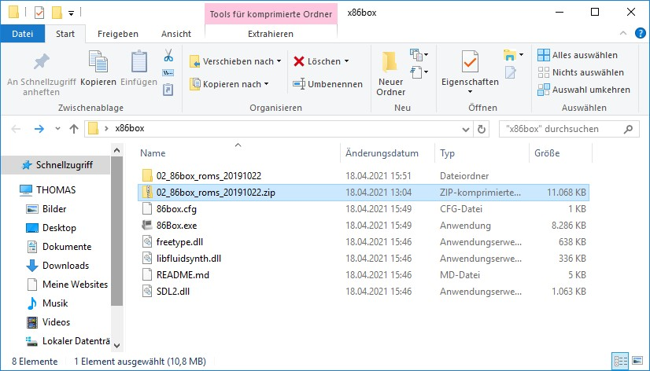
Delete the ZIP archive and rename the folder 86box_roms... to "ROMS". The result should look something like this:
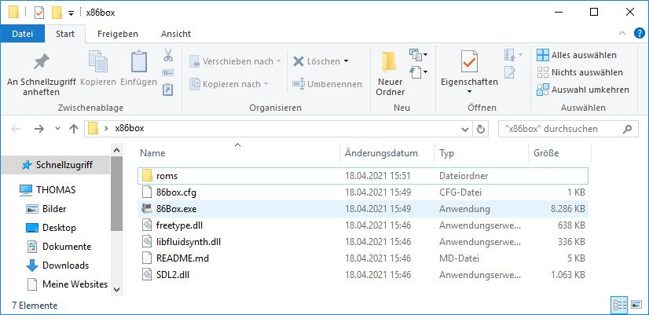
The following subfolders are contained in the roms folder:
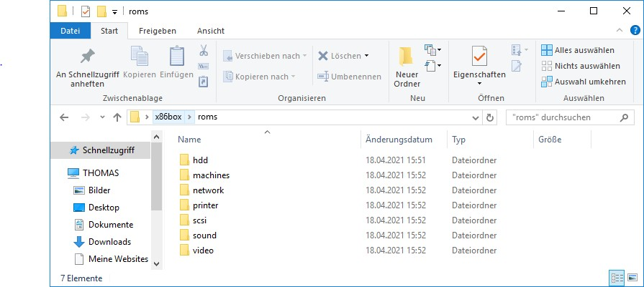
Step 3 – First start
Now start the 86box.exe by double-clicking. The image flickers a few times and after about
For 30 seconds you can see the basic interpreter on an emulated IBM PC from 1981.
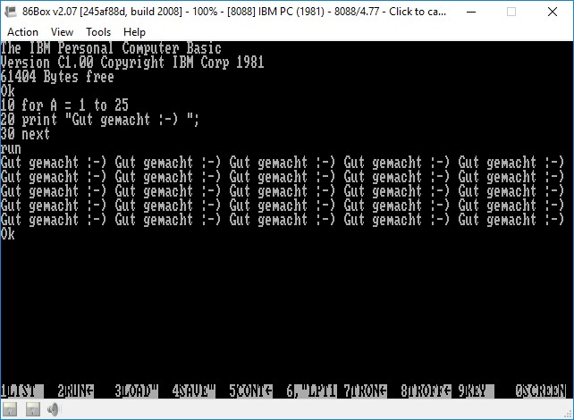
To "get out" of the emulation window, press Alt+TAB on the keyboard.
Step 4 – Amstrad/Schneider PC 1512 Startup Disks
You will now need the system disks for the PC1512 in the so-called .dsk format. You will discover them on the Internet after some time. The set consists of:
DISC 1 | Microsoft MS-DOS Operating System, Start-Up and Utilities v3.2 46001/G  Red Disk
DISC2 | GEM Start-Up v2.0U  46002/G  Blue Disk
DISC3 | GEM Desktop v2.0U / Locomotive Basic 2 v1.0  46003/G  Green Disk
DISC4 | DosPlus Start Up and Utilities v1.2/GEM PAINT v1.0U 46004/G  Yellow Disk

Create a folder in your 86Box directory and name it "fdd" for example and copy floppy disk images into the directory. The folder should look something like this:
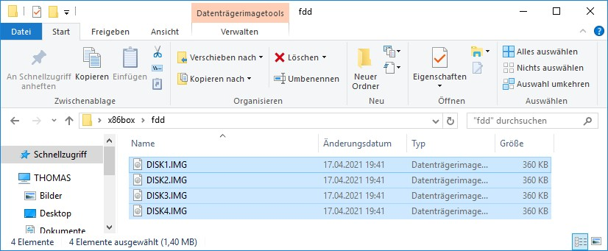
Step 5 – Creating a Hard Drive
Create a folder in your 86Box directory and name it "hdd", for example.
Now click on the menu command "Tools" in the 86Box program and then on "Settings". Click on "Hard Disks" in the menu structure on the left and select the command "New" in the lower area.
For Bus, select "MFM/RLL" and for Type, select "20 MB (CHS: 614, 4, 17)"
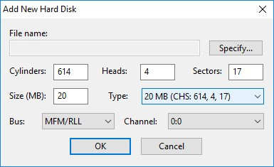
Then click on the "Specify" button to create the file. Select your folder for 86Box and the HDD folder it contains. For example, name the file pc1512platte, click "Save" in the file dialog, and click "OK" in the "Add New Hard Disk" dialog. The following message will appear:
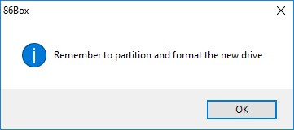
Step 6 – Switching to PC1512
Click on "Machine" in the configuration dialog and select the entry "[8086] Amstrad PC 1512", increase the RAM to 640 kilobytes under "Memory". Be sure to leave the settings under "Configure" on "PC-CM (Colour)", "US English" and "English".
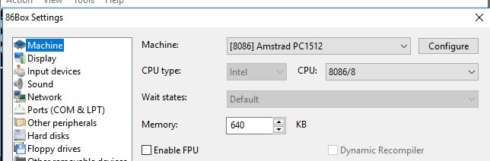
In the configuration dialog, select "Other peripherals" and select "[ISA] [MFM] ST-11M Fixed Disk Adapter" under HD Controller.
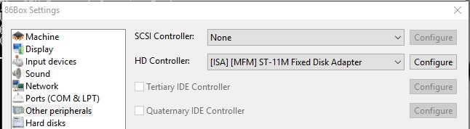
Under "Input devices" under "Mouse", select "Internal Mouse".
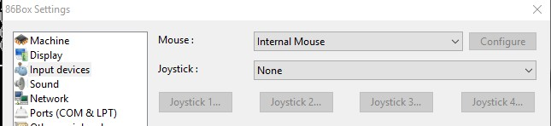
Under "Display", select "Video" – "Internal".
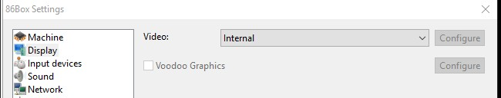
Confirm all entries by clicking on "OK" at the bottom of the window. A warning dialog appears, which you confirm with "Yes":
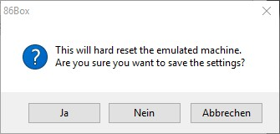
Your emulated PC 1512 now boots for the first time and after about 30 seconds the following dialog box appears for setting up the hard drive (low-level formatting):
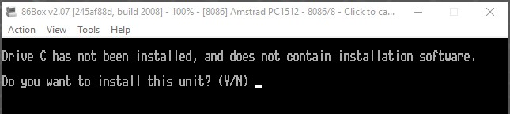
Confirm with "Y" and press Enter. Now enter the following characteristics of the emulated disk:
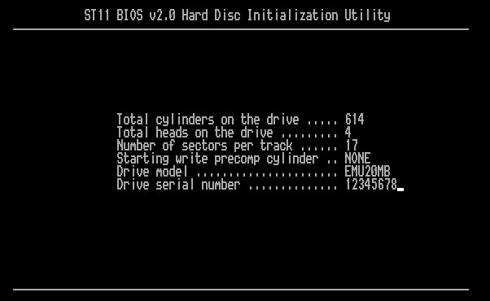
Set the "Interleaving" to 3 or leave it at 4, it is irrelevant for the success of the operation. You will be asked again whether the inputs are so appropriate, confirm this dialog with "Y".
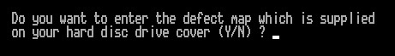
Answer the above question with "N" and press Enter.
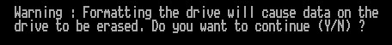
Confirm the above question with "Y" and press Enter, it will now take a few seconds for the hard drive to be formatted.
Step 6 – Start DOS
The emulated computer will now perform a reboot and greet you with a message that you should insert a system disk:
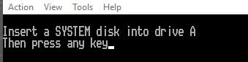
Click the left floppy disk icon at the bottom of the emulation window to insert a floppy disk into the emulated drive:
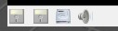
Select Existing Image from the menu and select DISK1. IMG
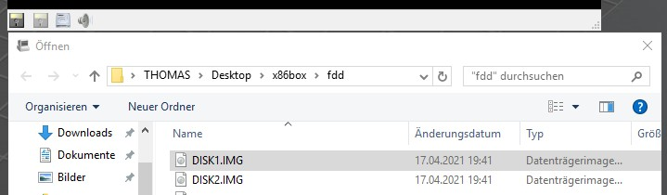
Click the mouse pointer in the 86Box window and press a key. MS-DOS starts:
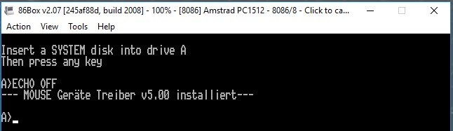
Step 7 – Set up disk partition
Type the fdisk command and confirm the entry with the Enter key.
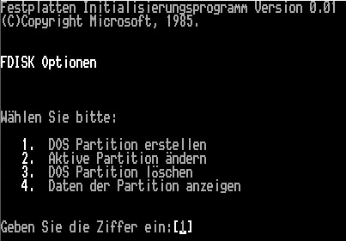
Select the "1" option.
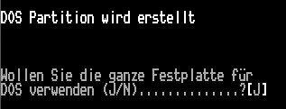
Confirm the selection with "J".
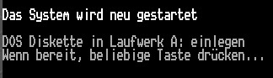
Press a key and your emulated PC 1512 will boot:
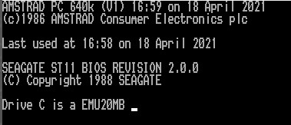
Step 8 – Transfer MS-DOS to Disk
Enter the following commands one at a time: format c:
sys c: copy a:*.* c:
Remove "Eject" the emulated floppy disk from drive A (via the floppy disk icon in the lower left) and click CTRL+ALT+DELETE under Action.
Done – Your PC1512 is ready to use – Have fun
Thomas Bär thomas@8und16bit.de

